TACO BELL HAWAII HONORED WITH COMMUNITY IMPACT AWARD AT BOYS & GIRLS CLUB OF HAWAII
January 19, 2026

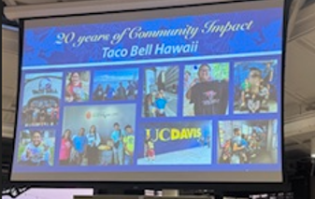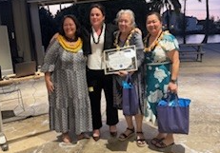

The Boys & Girls Club of Hawaii recently hosted their Corporate Board Annual General Meeting, where Taco Bell Hawaii was honored with the Community Impact Award for over 20 years of community support. Last year, The Taco Bell Foundation awarded Boys & Girls Club of Hawaii $55,000, which helped to support their programs. In addition, Taco Bell Hawaii continues to give back through food donations that help nourish youth across the community.

