BOYS & GIRLS CLUB OF HAWAII AND JUNIOR ACHIEVEMENT OF HAWAII AWARDED GRANTS THROUGH TACO BELL FOUNDATION’S
RECORD $28 MILLION INVESTMENT

The Taco Bell Foundation’s Community Grants are fueling youth success by funding
nearly 500 nonprofit organizations across the country.

HONOLULU, HI (FINAL) – The Taco Bell Foundation recently announced it is
awarding a record-breaking $28 million in Community Grants to nearly 500 nonprofit
organizations across the U.S., marking the largest annual grant investment in the Taco Bell Foundation’s 30+ year history. Among the local recipients are the Boys & Girls Club of Hawaii, awarded $55,000, and Junior Achievement of Hawaii, awarded $30,000 – two organizations supported by RBD Hawaii Restaurants Limited for their dedication to empowering O‘ahu’s youth through programs in education, mentorship, college access, and career readiness.

This $5 million increase over last year’s total underscores the Taco Bell Foundation’s deepened commitment to supporting youth in the communities where Taco Bell operates. RBD Hawaii Restaurants Limited is honored to be part of the process in identifying and uplifting the nonprofits that make the greatest impact in their communities. This year’s selected grantees reflect that close-to-home connection and the shared mission to expand access to opportunities for young people.

“We are pleased to support the Boys & Girls Club of Hawaii. Their programs provide a safe, inspiring space for thousands of local keiki, helping them unlock their full potential and build brighter futures,” said Yong Min Kim, Operations Director of RBD Hawaii Restaurants Limited. “We’re also excited to continue our partnership with Junior Achievement of Hawaii, whose hands-on learning programs prepare students to succeed in the real world. Together, these organizations represent the heart of our community.”

COMMUNITY-LED IMPACT THAT LASTS
This milestone year was made possible by something small: spare change. With an average Round Up donation of just 44 cents, Taco Bell fans, and the Team Members who inspire them, helped power life-changing impact across the country. In fact, the Taco Bell Foundation’s Round Up campaign was named the top point-of-sale fundraiser in Engage For Good’s 2025 America’s Charity Checkout Champions report, raising more than $50 million in 2024 – a 56% increase since 2022 and a powerful testament to the difference everyday generosity can make.

LOCALLY NOMINATED, NATIONALLY IMPACTFUL
Unlike many traditional grant models, the Taco Bell Foundation’s Community Grants program puts decision-making in the hands of those who know their communities best. Through this approach, organizations like RBD Hawaii Restaurants Limited help drive investments that reflect the real needs and priorities of local youth while contributing to a broader national impact.

In 2025, 45% of all Community Grant funding supported career readiness programs that equip young people with essential skills for the future. An additional 29% went toward academic success mentorship, and 11% focused on increasing college readiness, ensuring support reaches students at every stage of their educational journey. These grants complement the Taco Bell Foundation’s ongoing investments through the Live Más Scholarship program, which has awarded over $64 million since its launch a decade ago. In 2025, RBD Hawaii Restaurants Limited proudly awarded $14 million in Live Más Scholarships to Taco Bell Team Members, empowering them to pursue their educational goals and passions.

To learn more about the Taco Bell Foundation and the Community Grants program, please visit https://www.tacobellfoundation.org/who-we-support/.

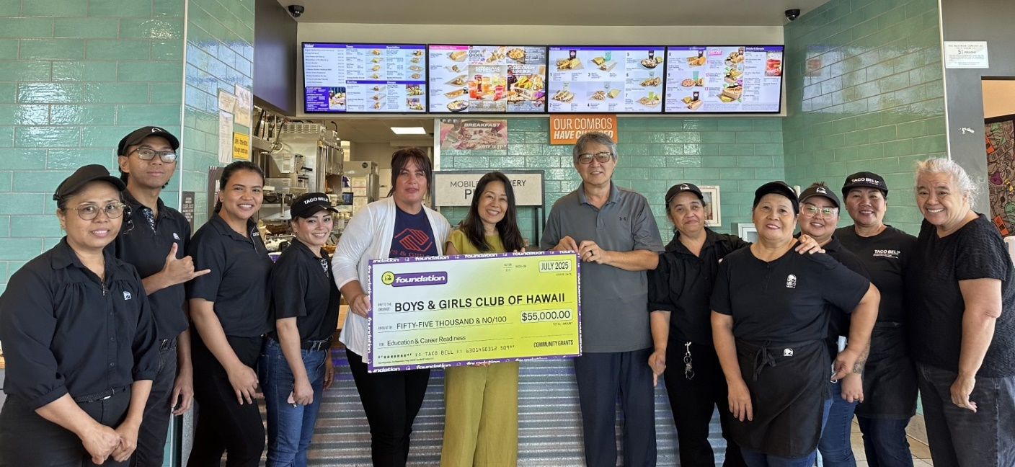
Boys & Girls Club of Hawaii Check Presentation (left to right): Taco Bell Kalihi crew members pictured with Inglish Jones, Director of Development, Boys & Girls Club of Hawaii; Leah Allen, Marketing Director, RBD Hawaii Restaurants Limited; Yong Min Kim, Operations Director, RBD Hawaii Restaurants Limited; and Valerie Agustin, Field Training Supervisor, RBD Hawaii Restaurants Limited.

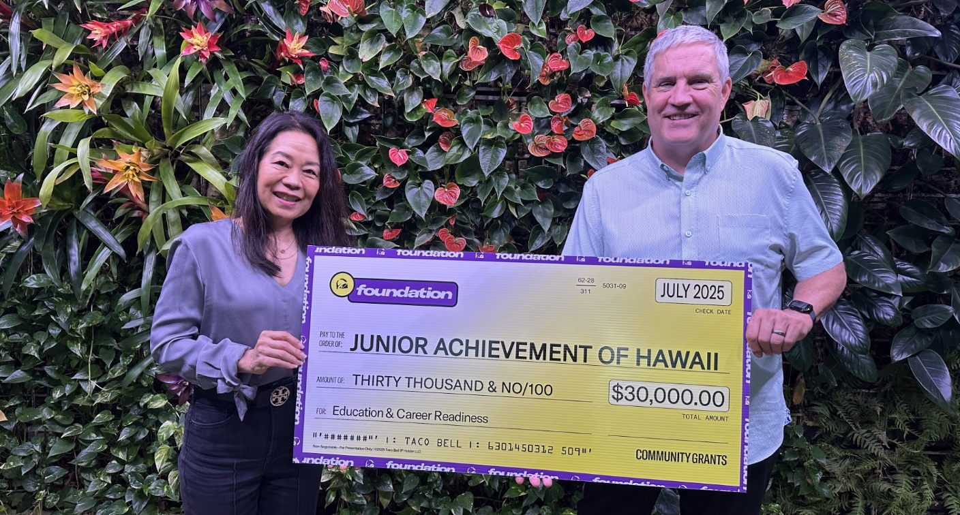
Jr. Achievement of Hawaii Check Presentation (left to right): Leah Allen, Marketing Director, RBD Hawaii Restaurants Limited; David Earles, President, Jr. Achievement of Hawaii.

About RBD Hawaii Restaurants Limited
RBD Hawaii Restaurants Limited operates 57 Pizza Hut and Taco Bell restaurants throughout the Hawaiian Islands and 13 Pizza Hut and Taco Bell restaurants in Guam and Saipan.

About Taco Bell Foundation
Taco Bell Foundation, Inc. is a 501(c)(3) public charity that empowers the next generation to pursue their passions by breaking down barriers to education and providing resources to help young people chase their boldest ambitions. Since 1992, the Taco Bell Foundation has reached nearly 9 million young people across the country and has awarded more than $203 million in grants and scholarships, focused on education and career readiness. For more information about the Taco Bell Foundation, visit www.tacobellfoundation.org.

# # #

